Right of Way Permit Payment Instructions
The online payment option is now available for right-of-way permits.
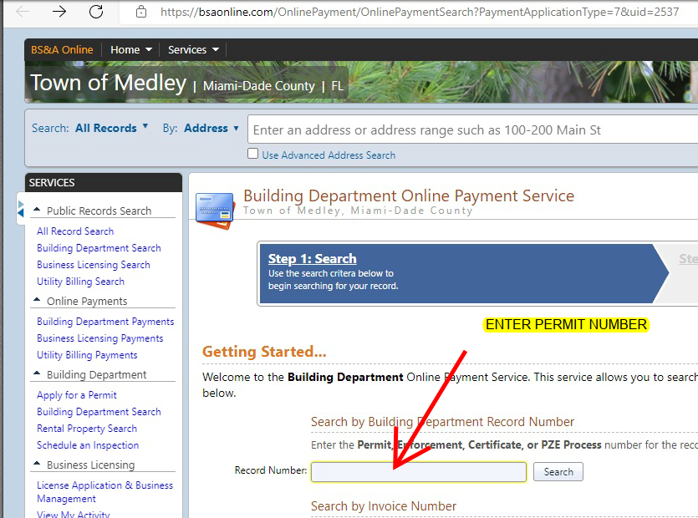
Please copy and paste the link below to your browser: https://bsaonline.com/OnlinePayment/OnlinePaymentSearch?PaymentApplicationType=7&uid=2537

